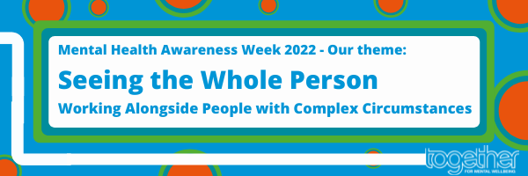**Mental Health Awareness Week 2022**

**Seeing the Whole Person – Working Alongside People with Complex Circumstances**

Mental Health Awareness Week 2022 runs from Monday 9 to Sunday 15 May and for this year Together’s theme is **Seeing the Whole Person.**

We felt this theme would provide us with an opportunity to raise awareness and demonstrate the truly brilliant work we do as an organisation - to ensure we always consider every aspect of an individual’s experience, including mental, physical and social, as we work alongside the people who use our services to lead their own care and support.

The circumstances and life events for the people who come through our doors, or where we meet them in other settings, often encompass a range of difficult and traumatic experiences, which may have led to or exacerbated their lived experience of mental distress, such as homelessness, substance misuse, poverty or abuse as some examples.

In line with our values and service user leadership principles, we want to use this week to bring alive and illustrate our holistic and inclusive approach to supporting people who have often been impacted by multiple and interconnected challenges in their lives.

It is also an opportunity to demonstrate how we recognise strength in vulnerability, as we work alongside people so they can feel empowered to navigate their journey to improved wellbeing despite the often incredibly difficult hurdles they may face along the way.

During the week, we will be sharing stories from the people who use our services who have experienced a range of life challenges and looking at the way our staff have worked alongside them. Because the people who will be sharing their lived experiences have faced difficult and complicated situations often the names used will be changed to provide them with anonymity. Some of the content shared during the week will be accompanied by content warnings as well because of the serious and difficult nature of some of the experiences.

During the week we will be using the hashtag **#SeeingTheWholePerson** and hope to show the importance of taking into account the full lived experiences of the people who use our services and the incredible strength and resilience they show.